History Department Curriculum Plan
Curriculum Intent
The recent revision of our curriculum has led us to move to a chronological style of teaching at KS3, rather than the previous thematic approach. The curriculum covers the time period from 43AD to the present day, with a special emphasis on the concepts of Church, Power and Diversity.
Our curriculum intends for students to:
- Develop a sense of “period” for the different time periods they are studying so that they can explain similarities and differences between time periods and identify areas of progress or regression.
- Understand how concepts such as Church and Diversity change over time, and how they have impacted on the different time periods studied.
- Identify specific events and people as significant in history, and explain their importance.
- Recognise the part played by Devon and the local area in national and international history.
- Develop their procedural knowledge of the writing of history by analysing sources and comparing interpretations.
- Make links between history they have studied previously, and their current topic of study.
A breakdown of how this will look for students as they make their journey through the college is outlined in the table below.
History Department ECC Curriculum Milestones
Year Group | Subject knowledge milestones  (by curriculum emphasis) | Procedural knowledge milestones
 |  | Sources | Interpretations
7 | Church  - Students understand that the “Church” is an institution as well as a building.  - Students know why the church was so important and can give examples of its role in society | - Students know what a source is.  - Students understand that historians use sources to find out about the past.  - Students can make an inference from a source  - Students are able to quote from a source  - Most students can identify provenance of a source | - Students know what an interpretation is.  - Students understand that historians use sources to write an interpretation.  - Students can identify the meaning of an interpretation by looking at language used
Power
- Students understand the way that medieval society was structured and the power that the monarch had
- Students can give examples of the ways medieval monarchs kept control

Diversity
- Students know why people have migrated to Britain
- Students can give example of the ways migrants have contributed to British culture.
8 | Church  - Students know that the power of the church was challenged during the Reformation  - Students understand that from 1500s religious views in Britain (and Europe) were divided  - Students know that from 1700s the development of scientific knowledge led to a decline in the power of the church. | - All students understand what the provenance of a source is  - Students know what it means for a source to be reliable  - Students can suggest ways in which the provenance of a source can impact its reliability | - Students are able to support and challenge interpretations of history using their own knowledge  - Some students can make a judgement on whether they agree with an interpretation based on knowledge.
Power
- Students know that from 1500s parliament grew in importance
- Students understand that Britain became a powerful force in the world through the British Empire
- Students can give examples of positive and negative uses of power during the period 1500-1900.

Diversity
- Students know that exploration led to an increase in the diversity of Britain
- Students understand how slavery in USA impacted on society in USA and Britain and link this to present day
- Students can give examples of civil rights actions

9 | Church  - Students understand that during the 20th century the church became a less important factor of change and that government and technology become more significant  - Students know that the Holocaust was an act of extreme violence against Jewish people and can suggest ways that this should be remembered. | - Students are able to use the content of a source to suggest reasons it may be considered useful for historians  - Students are able to use the provenance of a source, and its reliability, to suggest reasons it may be considered useful for historians  - Students are able to make a judgement on how useful a source is for historians | - Students are able to support and challenge an interpretation using sources  - Students are able to make a judgement on whether they agree with an interpretation based on sources and knowledge.
Power
- Students know how countries competing for power led to world wars
- Students understand how women gained more political power in 20th century and can give examples of the impact of this
- Students understand the concept of dictatorship and can give differences between communism and capitalism

Diversity
- Students know the importance of the role played by soldiers from the British Empire in both world wars
- Students know that the socio-economic disparity within society has become less acceptable since 1900
10 | Medicine Through Time  - Students know the difference between the different time periods studied(in terms of factors of change) and understand the chronology of the course  - Students are able to give examples of ideas about the cause of disease, knowledge of anatomy, and attempts to treat or prevent disease for each time period studied  - Students know the importance of the Western Front during WW1 for the development of surgery. | - Students are able to assess the utility of two (or more sources) at once  - Students can make a clear supported judgement on the utility of sources using both content and provenance. | - Students are able to compare interpretations and describe ways in which they differ  - Students are able to suggest reasons for the difference in interpretations  - Students are able to make a clear and supported judgement on the validity of an interpretation using detailed knowledge and sources.
Weimar and Nazi Germany
- Students know the impact of WW1 on Germany, how and why the Weimar Government was set up and can give examples of the problems they faced
- Students understand why the Nazis had little success in 1920s and can give examples of efforts made to help Germany recover
- Students know how Hitler came to power and can give examples of the impact Nazi rule had on groups within society

11 | Superpower Relations and the Cold War  - Students know why tension developed between the superpowers after WW2  - Students can give examples of events throughout the period that led to increased tension, and those that decreased tension  - Students know why the Cold War ended when it did and the role played by individuals
Henry VIII and his ministers
- Students know why the different ministers rose to power and can give examples of the reforms they introduced
- Students understand the position of England within Europe at the time and how relations between the countries impacted on domestic policy
- Students know why Henry VIII reformed the church and can give examples of the changes made

12 | Cold War in Asia  - Students can give examples of Western Policies in SE Asia after WW2 and understand the reasons for these  - Students know the reasons for intervention in Korea and the impact of the Korean War  - Students understand the developments in Indochina from 1945 to 1967 and can put these in historical context  - Students know the reasons for increased US military intervention in Vietnam and Cambodia, and can assess the reasons behind US failure | - Students can assess the support and challenge multiple sources offer an interpretation, using a provenance and a detailed knowledge of the historical context.  - Students can use a variety of sources to support and challenge a historical argument, taking note of the provenance and typicality of the views expressed | - Students can locate interpretations within the wider historical debate to assess their validity  - Students are able to analyse the provenance of interpretations and use this to support or challenge the view given  - Students can use multiple interpretations to support or challenge a wider historical argument
Russia and its Rulers
- Students understand the differences in the nature of governments throughout the period
- Students know the impact of dictatorial regimes on the economy and society of the Russian Empire and the USSR
- Students know Impact of war and revolution on the development of the Russian Empire and the USSR
- Students have an understanding of Russia: Empire, nationalities and satellite states

13
The Later Tudors
- Students know the issues faced by England during the “Mid Tudor Crisis” and can assess their severity in relation to each other.
- Students understand the religious position of Elizabeth I and the challenges faced by the Elizabethan government from Catholics and reformists
- Students know how the Elizabethan government developed during the time period and can evaluate their success in dealing with challenges

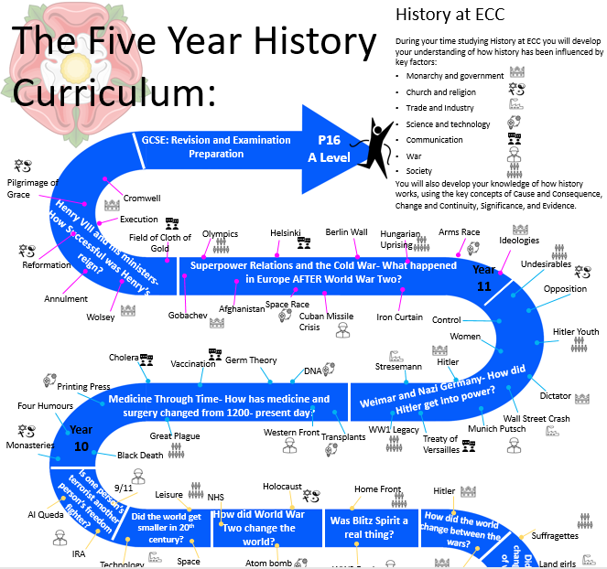
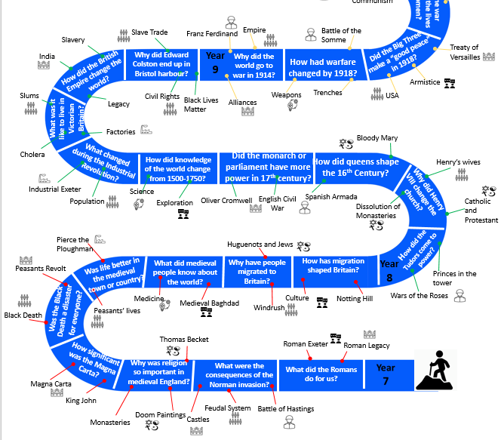
Curriculum Implementation
The implementation of this intent is achieved by the following:
- The teaching of engaging lessons with a clear focus and enquiry based approach.
- Retrieval practise with a focus on knowledge that supports the understanding of the key concepts
- A supported approach to the use of sources and interpretations in lessons- scaffolding the procedural knowledge to develop the analytical writing over time.
- An emphasis on using interpretations in lessons to develop the literacy skills required of ambitious history teaching.
- Encouraging students to develop an interest in History beyond the lessons- links to podcasts and historical articles on the knowledge organisers and provided in lessons.
- Regular quality assurance to enable sharing of good practice and ensure consistency of the experience of students across the department.

Curriculum Impact
As a result of these actions the following impacts should be evident:
- Students have a consistent experience of History teaching across the college.
- Students are confident in their historical understanding and have a clear sense of “period” for the different time periods they have studied.
- Students are confident in their ability to analyse sources and interpretations
- Students can see how the key concepts have changed and progressed over time.
- Students are able to make comparisons between time periods and are able to justify clear historical arguments.
- Students are aware of how the time period they are currently studying fits in with their previous learning.
- Students enjoy their History lessons and recognise the value of studying History to a higher level.

