HEALTH AND SOCIAL CARE – COMP 3 KNOWLEDGE ORGANISER
B1 Physiological indicators
Interpretation of physiological data according to published guidelines
- Resting heart rate (pulse) - normal range 60 to 100 bmp
- Heart rate (pulse) recovery after exercise – the heart’s ability to return to normal levels after physical activity is a good indicator of fitness
Blood pressure (BP)

- low blood pressure 90/60mmHg or lower,
- ideal blood pressure between 90/60mmHg and 120/80mmHg
- pre-high between120/80mmHg and 140/90mmHg
- high blood pressure 140/90mmHg or higher

- systolic, diastolic, hypertension, hypotension, causes, short
term and long term risks, how to reduce high blood pressure

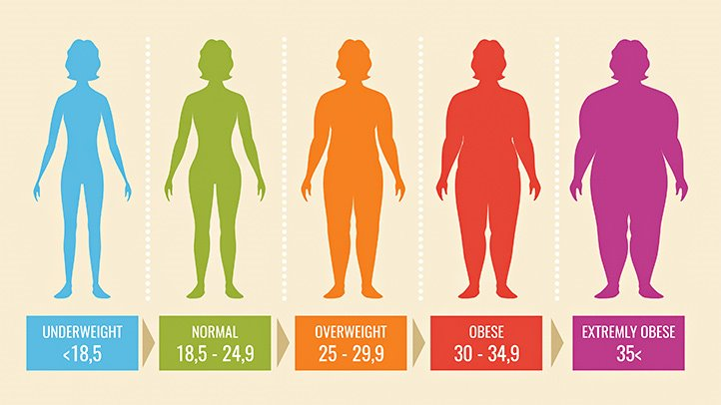
Body mass index (BMI)
- underweight below 18.5 kg/m2
- healthy weight between 18.5 kg/m2 and 24.9 kg/m2
- overweight between 25 kg/m2 and 29.9 kg/m2
- obese between 30 kg/m2 and 39.9 kg/m2
- severely obese 40 kg/m2 or above

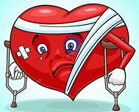
The potential significance of abnormal readings:
- Impact on current physical health (short-term risks)
- Potential risks to physical health (long-term risks)

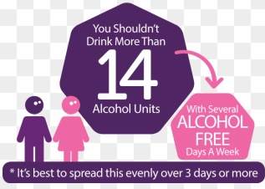
How lifestyle choices can determine physical health
Interpretation of lifestyle data according to published guidelines:
- Nutrition – the Eatwell Guide
- Physical activity – UK Chief Medical Officers’ Physical Activity Guidelines (how much?)
- Smoking – UK Chief Medical Officers’ Smoking Guidelines
- Alcohol – UK Chief Medical Officers’ Alcohol Guidelines (how many units?)
- Substance misuse – prescription drugs, illegal drugs, smoking, alcohol

