HEALTH AND SOCIAL CARE – COMP 2 KNOWLEDGE ORGANISER
A3 Barriers to accessing H&SC service and how they can be overcome
Barriers to accessing services - explore barriers that can make it difficult for service users to use services and suggest how the barriers can be overcome.
Definition of barriers:
- something unique to the health and social care system that prevents an individual to access a service.
Types of barrier and how they can be overcome by the service providers or users
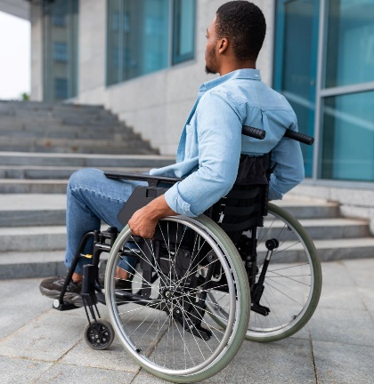
- physical barriers – issues getting into and around the facilities
- ways to overcome physical barriers: ramps, wider doorways, accessible toilets/rooms, stair lifts, hoists
- barriers to people with sensory disability – hearing and visual difficulties
- ways to overcome sensory barriers: hearing loops, British Sign Language (BSL) interpreters, communication cards, large print leaflets, braille leaflets, staff collecting vulnerable service users from waiting areas
- barriers to people with different social and cultural backgrounds – lack of awareness, differing cultural beliefs, social stigma, fear of loss of independence
- ways to overcome social and cultural barriers: awareness campaigns, posters and leaflets, well women and well men clinics, choice of service provider (e.g. if a male or female is preferred), collaboration with community and faith groups
- barriers to people that speak English as an additional language or those who have language or speech impairments
- ways to overcome language barriers: literature in other languages, face-to-face and telephone interpretation services, health and wellbeing group meetings for speakers of other languages, longer appointments, use of advocates, staff training and awareness of common speech and language difficulties
- geographical barriers – distance of service provider, poor transport links
- ways to overcome geographical barriers: local community transport schemes for disabled or elderly service users, home/community visits, community clinics, telehealth schemes o barriers for people with learning disabilities
- ways to overcome intellectual barriers: use of Health Passports and All About Me documents, use of advocates, use of Learning Disability Nurses (LDNs) and support workers, ‘Quiet Clinics’, quiet waiting areas, longer appointment times, use of communication cards, adhering to The Accessible Information Standard and providing low text ‘easy read’ leaflets
- financial barriers – charging for services, cost of transport, loss of income while accessing services
- ways to overcome financial barriers: NHS exemption certificates, NHS Low Income Scheme, NHS vouchers for eye tests, glasses and lenses, NHS Healthcare Travel Costs Scheme (HTCS), charitable schemes such as community transport

