Transition Pack for A level physics
So you want to take A level Physics next year?! We want you to also. It is the greatest subject in the universe, it is also one of the most challenging and misunderstood so to really hit the ground running you need to brush up on the basics and this is a great time to do that while stuck at home.

Main Tasks:
1. Write a paragraph on TED talks: Watch some of the following TED talks and write a paragraph of your thoughts afterwards (1 each)
https://www.ted.com/talks/joe_lassiter_we_n eed_nuclear_power_to_solve_climate_chang e?language=en
https://www.ted.com/talks/helen_czerski_ fun_home_experiments_that_teach_you_ physics?language=en
https://www.ted.com/talks/brian_greene_wh y_is_our_universe_fine_tuned_for_life?langua ge=en
https://www.ted.com/talks/regina_dugan_f rom_mach_20_glider_to_humming_bird_dr one/up-next?language=en

2. Familiarise yourselves with the following websites, they offer excellent resources that you may wish to go back to in the future.
https://home.cern/
http://www.physics.org/aboutus.asp
https://www.alevelphysicsonline.com/

3. Go through the AQA Transition pack front to back. Print it off if you are able so that you can fill in the answers as you go through and you will need to hand that document in in September. (If you are not able you will need to work on lined paper.

4. Make a list of you 3 favourite physics youtube videos and bring with you to your first lesson. We can watch some and discuss the physics as an ice breaker activity.

Additional Tasks:
You have lots of time, lets put it to good use.
1. Read a Book: Read one or more of the books below, write a brief summary (2 sides of A4 max) to read out to the class in September.

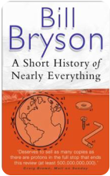

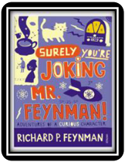
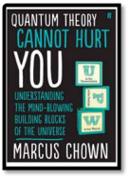
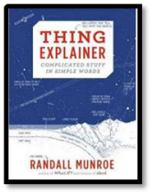
2. Watch these movies: If you can get hold of any of these movies, watch them and tell the class what you thought in September. What skills and science knowledge where required by the characters in these movies?
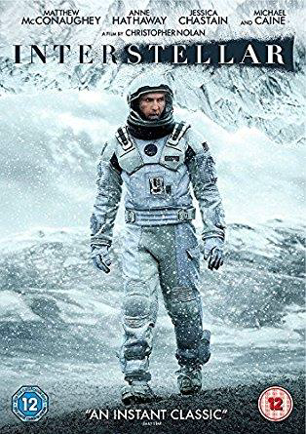
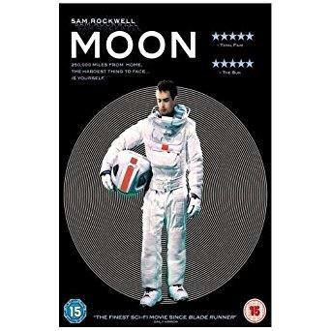

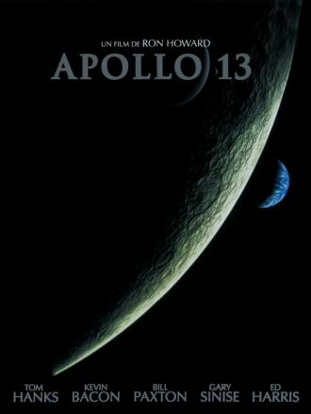

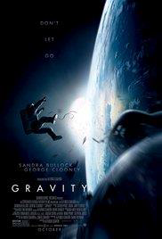
3. Look these up/follow on social media.
Follow on Twitter:

Commander Chris Hadfield –former resident aboard the International Space Station @cmdrhadfield

NASA’s Voyager 2 –a satellite launched nearly 40 years ago that is now travelling beyond our solar system
@NSFVoyager2

Neil deGrasse Tyson –Director of the Hayden Planetarium in New York @neiltyson

The SETI Institute –The Search for Extra Terrestrial Intelligence, be the first to know what they find! @setiinstitute

Phil Plait –tweets about astronomy and bad science @badastronomer

Institute of Physics –The leading scientific membership society for physics @PhysicsNews

Scientific America –Journal sharing discoveries and insights into science that develops the world @sciam

SN Students –Science news for students @SNStudents

Facebook:

National Geographic -since 1888, National Geographic has travelled the Earth, sharing its amazing stories in pictures and words.

Science News Magazine -Science covers important and emerging research in all fields of science.

BBC Science News -The latest BBC Science and Environment News: breaking news, analysis and debate on science and nature around the world.

Institute of Physics -The Institute of Physics is a leading scientific membership society working to advance physics for the benefit of all.

Chandra X-ray Observatory -NASA’s Chandra X-ray Observatory is a telescope specially designed to detect X-ray emission from very hot regions of the Universe such as exploded stars, clusters of
galaxies, and matter around black holes.

Interesting Engineering -Interesting Engineering is a cutting edge, leading community designed for all lovers of engineering, technology and science.

