HEALTH AND SOCIAL CARE – COMP 2 KNOWLEDGE ORGANISER
A1 & A2 Healthcare and Social Care Services

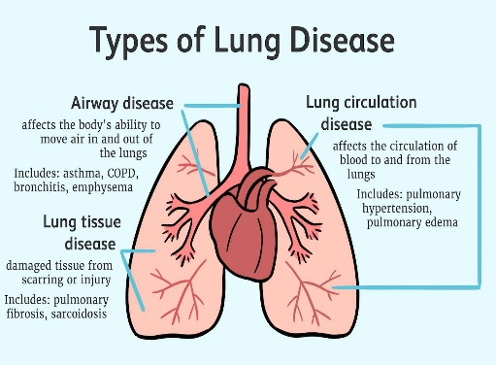
A1 Healthcare conditions and how they can be managed
- Arthritis
- cardiovascular conditions – coronary heart disease, cerebral vascular accident
- diabetes (type 2)
- dementia
- obesity
- respiratory conditions – asthma, chronic obstructive pulmonary disease (COPD)
- additional needs – sensory impairments, physical impairments, learning disability

Health services available:
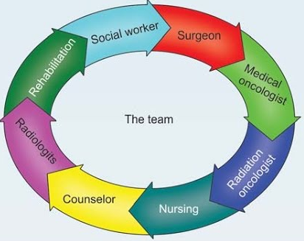
- primary care – GP surgeries, dental care, out-of-hours services, telephone services, accident and emergency departments
- secondary care – specialist medical care to include rheumatology, respiratory medicine, cardiology, endocrinology
- tertiary care – specialist medical care to include oncology, transplant services
- allied health professions – physiotherapy, speech and language therapy, occupational therapy, dietetics
- multidisciplinary team working – how services work together, including referrals between services

A2 Social care needs and social care services available to support the needs:
Social care – help with day-to-day living because of illness, vulnerability or disability.
Social care services:
- services for children and young people – foster care, residential care, youth work
- services for adults or children with specific needs (learning disabilities, sensory impairments, long-term health issues) – residential care, respite care, domiciliary care
- services for older adults – residential care, domiciliary care.
Additional care:
- informal care – given by relatives, friends, neighbours, partners
- voluntary care – community groups and faith-based organisations, charities

