B1 Skills and attributes in health and social care
- problem solving  - observation  - dealing with difficult situations  - organisation | Attributes:  - empathy  - patience  - trustworthiness  - honesty
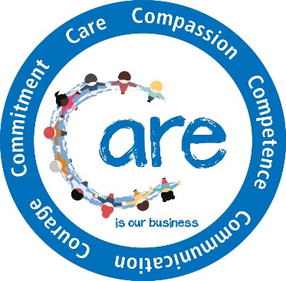
B2 Values in health and social care
The 6 Cs:
- care – receiving correct and consistent care
- compassion – empathy, respect and dignity
- competence – skills and knowledge to deliver effective care, based on research
- communication – involving individuals and/or carers and listening
- courage – doing the right thing and speaking up when concerns arise
- commitment – to improve care and experience for individuals
B3 The obstacles individuals requiring care may face
Definition of obstacles
- something personal to an individual that blocks a person moving forward or when action is prevented or made difficult
Potential obstacles and their impact on the individual:
- emotional/psychological – lack of motivation, low self-esteem, acceptance of current state, anxiety, stress
- time constraints – work and family commitments
- availability of resources – financial, equipment, amenities
- unachievable targets – unachievable for the individual or unrealistic timescale
- lack of support – from family and friends
- other factors specific to individual – ability/disability, health conditions, addiction.
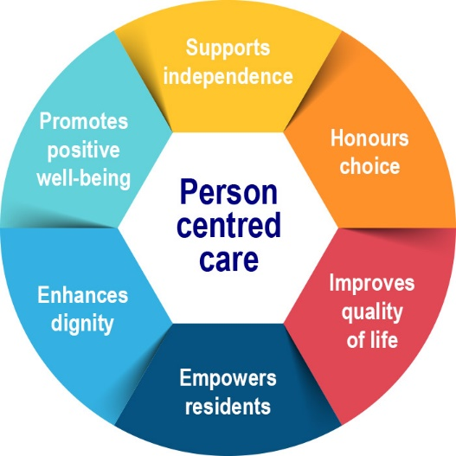
B4 The benefits to individuals of the skills, attributes and values in health and social care practice
- be supported to overcome their own personal obstacles
- receive high quality care
- receive person-centred care based on individual wishes
- be treated with respect
- not be discriminated against
- be empowered and have independence
- be involved in care decisions
- be protected from harm
- feel comfortable to raise complaints
- have their dignity and privacy protected
- have their confidentiality protected
- have their rights promoted

